Our concentration in this Chapter is to find the area bounded by curves, length of curves, volume and surface area of solids of revolutions with a general formula or with the help of definite integration.

Area under curves (Quadrature)

The mathematical term 'area' can be defined as the amount of two-dimensional space taken up by an object. The use of area has many practical applications in building, farming, architecture, science, and even deciding how much paint you need to paint your bedroom. The area of a shape can be determined by placing the shape over a grid and counting the number of squares that the shape covers, like in this image:

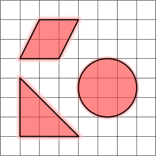

The area of many common shapes can be determined using certain accepted formulas. But it is not possible to determine the area of a zigzag region by normal formula. So in this case we calculate the area of such types of region by Integration.

The concept of area is very much used in real life. Designing your own apartments, rearranging the things in your room to get more space, designing your garden, etc. all these involve the amount of area you have to work with.

The process of finding the area, bounded by any defined contour line (i.e. a curve) is called quadrature.

**Area formula for Cartesian equation:** These equations involve *x* and *y*.

1. The area bounded by the curve , the x-axis and the lines  is



where  is a continuous single valued function and *y* does not change sign for .



1. The area bounded by the curve , the y-axis and the lines  is



where  is a continuous single valued function and *x* does not change sign for .



1. The area bounded by the curves ,  and the lines  is



where  is the upper curve and  is the lower curve.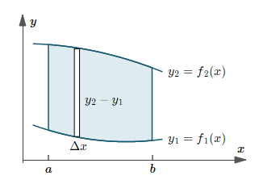

1. The area bounded by the curve Symmetry about the-axis is,



1. The area bounded by the curve Symmetry about the-axis is,



**Symmetry about the -axis:** If all the powers of *y* occurring in an equation are even then it is symmetry about the ****-axis. For example, ****is symmetry about the ****-axis.

**Symmetry about the -axis:** If all the powers of *x* occurring in an equation are even then it is symmetry about the ****-axis. For example, ****is symmetry about the ****-axis.

**Symmetry about the both** **axis:** If all the powers of *x* and y occurring in an equation are even then it is symmetry about the both axis. For example, ****is symmetry about the both axis.

**Symmetry about the line:** If the equation of the curve remains unaltered when *x* and y are interchanged, then the curve is symmetrical about the line ****.For example, ****, ****.

**Symmetry about the line:** If the equation of the curve remains unaltered when *x* and y are changed to  and**** respectively, then the curve is symmetrical about the line ****. For example, ****.

**Mathematical Problems**

**Problem 01:** Find the area bounded by the curve , the and the straight lines and .

**Solution:** We have, and.

The graph of the given curve is,

Y

X



O





The area of the region is,









** Sq. Units.**

**Problem 02:** Find the area bounded by the curve , the and the straight lines and .

**Solution:** We have, and.

The graph of the given curve is,

Y



X

O





The area of the region is,







** Sq. Units.**

**Problem 03:** Find the area bounded by the curve , the and the straight lines and .

**Solution:** We have, and.

The graph of the given curve is,

Y



X

O





The area of the region is,





** Sq. Units.**

**H.W:**

**1.** Find the area bounded by the curve , the and the straight lines and .

**2.** Find the area bounded by the curve , the and the straight lines  and .

**3.** Find the area bounded by the curve , the and the straight lines  and .

**Problem 04:** Find the area of the region bounded by the curve ; from and .

**Solution:** We have,and.

Since, only even power of *y* occurs in the given curve so the curve is symmetric about the *x*-axis.

The graph of the given curve is,

Y



X

O



Also, the given curve can be written as,





The area of the region is,















** Sq. Units.**

**Problem 05:** Find the area of the region bounded by the curve  and *y*-axis.

**Solution:** We have,

Since, only even power of *y* occurs in the given curve so the curve is symmetric about the *x*-axis.

The graph of the given curve is,

Y



X

O







Putting in (1) then we have  , so the vertex is at .

Also putting in (1) then we have. So the curve crosses the *y*-axis at andThe given curve can be written as,





The area of the region is,

















** Sq. Units.**

**H.W:**

1. Find the area of the region bounded by the curve ; from and .

2. Find the area of the region bounded by the curve ; from and .

**Problem 06:** Find the area of the region enclosed by and.

**Solution:** The equation of the given curves are  and.

The graph of the given curves is as follows:

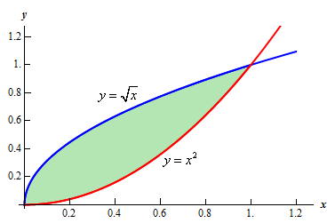

We have

and

Now,



 [Squaring both sides]







Therefore, and 











For real we get respectively 

Therefore, the given curves intersect each other in two point at and.

In the question, **.**

So, the area of the region is,

















** Sq. Units. ( As desired)**

**Note:** It is noted that when we calculate the area with respect to x or y axis we get the same result.

**Problem-07:** Obtain the area of the region enclosed by and.

**Solution:** The equation of the given curve is  and also the straight line is.

The graph of the given curve and straight lines are as follows:

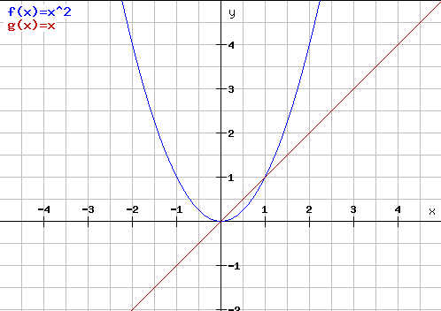

We have

and

Now,







Therefore 



For real we get respectively.

Therefore the given point of intersection of curve and straight lines are and.

In the question ,**.**

So, the area of the region is















** Sq. Units. (As desired)**

**Problem-08:** Determine the area of the region bounded by and.

**Solution:** The equation of the given curve is  and also the straight line is.

The graph of the given curve and straight lines are as follows:

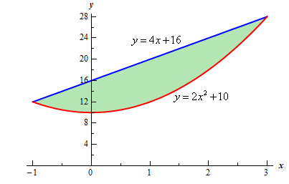

We have

and

Now,















Therefore 



For real we get respectively.

Therefore the given point of intersection of curve and straight lines are and.

In the question, **.**

So, the area of the region is























** Sq. Units. (As desired)**

**Problem-09:** Determine the area of the region bounded by and the

y-axis.

**Solution:** The equation of the given curves are and also the straight lines areand the y-axis.

The graph of the given curve and straight lines are as follows:

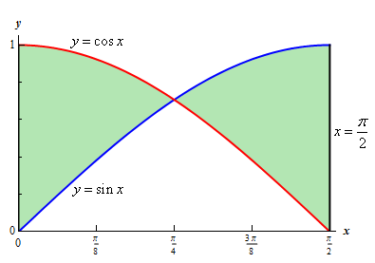

We have,



Now,











For real value  we get

.

Therefore the point of intersection of given curves is .

In the question, ****but our outer function is not same always.

So, the area of the region is





















** Sq. Units (As desired)**

**Problem-09:** Prove that the area of the circle isSq. Units.

**Proof:** The equation of the circle is. Clearly the given equation represents a circle its Centre is in  and radius is “ a ” units.

The graph of the given circle is as follows:

**a**

We have,

The equation of the circle is .

Now,







In the question, **.**

So, the area of the region is

** [Since a circle have four symmetric part]**





Say  such that.

Limit:

When then .

When then.

Now,















** **









** Sq. Units (As desired )**

**Problem-10:** Prove that the area of the ellipse isSq. Units.

**Proof:** The equation of the ellipse is. Clearly the given equation represents a ellipse its vertex is in , the length of major axis is “ 2a” and minor axis is “2b”.

The graph of the given ellipse is as follows:

**a**

We have,

The equation of the ellipse is .

Now,













In the question, **.**

So, the area of the region is

** [Since aellipse have four symmetric part]**





Say  such that.

Limit:

When then .

When then.

Now,

















** **









** Sq. Units (As desired)**

**Procedure for tracing curves gives in Polar Form:**

1. **Symmetry:**
2. If by changing  into ****, the equation of the curve remains unaltered, then there is symmetry about the initial line. For example, **,** .
3. If by changing  into ****, the equation of the curve remains unaltered, then there is symmetry about the line through the pole and perpendicular to the initial line.
4. If by changing  into ****, the equation of the curve remains unaltered, then there is symmetry about the pole.
5. If by changing  into  and  into ****, the equation of the curve remains unaltered, then the curve passes through the pole and it is symmetrical there about the line which is perpendicular to the initial line.
6. If by changing  into ****, the equation of the curve remains unaltered, then the curve is symmetrical about the line ****.
7. The curve will pass through the pole if for some value of ****, the value of  comes out to be zero. Also if ****, when ****, then usually the line  will be a tangent to be curve at the pole.

The area bounded by the curve ****, where  is a single valued continuous function of  in the domain of  in the radii vectors  and  is



**Problem-11:** Find the area of the circle.

**Solution:** Given circle is 







The center of the given circle is at  and the radius is .

The whole area of the circle the area in the first quadrant i.e. area OABO.

The coordinates of A and B are  and respectively.

Since the area OABO is bounded by the curve (1), the *x*- axis and the lines , , where  varies from 0 to .

The graph of the given circle is as follows:

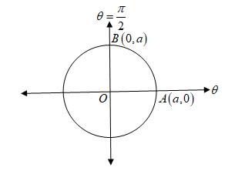

So, the area of the region OABO is

A 



****.

Hence the whole area of the given circle is



** Sq. Units (As desired )**

**Problem-12:** Find the area of the curve .

**Solution:** Given curve is 

In the given equation (i), 3 is an odd number so equation (i) has three equal loops.

Since by changing  into ****, the equation of the curve remains unaltered, then the curve is symmetrical about initial line.

For one loop, putting in (i) we have









.

So one loop lies between  and .

The graph of the given curve is as follows:

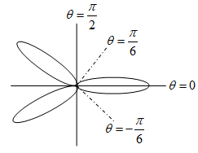

So, the required area of the curve is

A 











** Sq. Units (As desired )**

**NOTE:** If , then

1. the number of loops is , when is even.
2. the number of loops is , when is odd.

**Problem-13:** Find the area of the curve .

**Solution:** Given curve is 

In the given equation (i), 2 is an even number so equation (i) has four equal loops.

Since by changing  into ****, the equation of the curve remains unaltered, then the curve is symmetrical about initial line.

For one loop, putting in (i) we have









.

So one loop lies between  and .

The graph of the given curve is as follows:

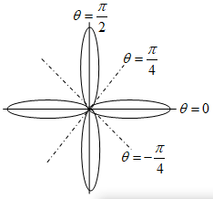

So, the required area of the curve is

A 











** Sq. Units (As desired )**

**Problem-14:** Find the area of the curve .

**Solution:** Given curve is 

In the given equation (i), 2 is an even number so equation (i) has four equal loops.

For one loop, putting in (i) we have







.

So one loop lies between  and .

The graph of the given curve is as follows:

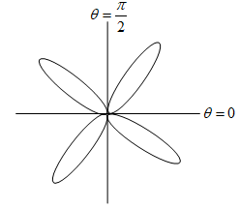

So, the required area of the curve is

A****









** Sq. Units (As desired )**

**Problem-15:** Find the area of the cardioid .

**Solution:** Given curve is 

Since by changing  into ****, the equation of the curve remains unaltered, then the curve is symmetrical about the initial line.

Now putting in (i) we have









.

So the curve lies between  and .

The graph of the given curve is as follows:

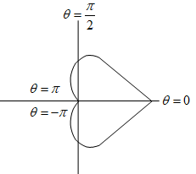

So, the required area of the cardiod is

A 















** Sq. Units (As desired )**

**Problem-16:** Find the area of the cardioid .

**Solution:** Given curve is 

Since by changing  into ****, the equation of the curve remains unaltered, then the curve is symmetrical about the initial line.

The graph of the given curve is as follows:

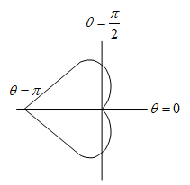

For the upper half of the curve, varies from 0 to .

So, the required area of the cardiod is

A 















** Sq. Units (As desired )**

**Problem-17:** Find the area of the cardioid .

**Solution:** Given curve is 

Since by changing  into ****, the equation of the curve remains unaltered, then the curve is symmetrical about the line through the pole and perpendicular to the initial line.

The graph of the given curve is as follows:

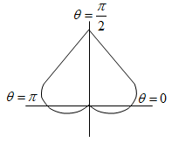

For the first quadrant, varies from 0 to .

So, the required area of the cardiod is

A 













** Sq. Units (As desired )**

**Problem-18:** Find the area of the loop of the curve .

**Solution:** Given curve is 

If *x* and *y* are interchanged, equation (i) remains unaltered and hence the curve is symmetrical about the line .

To transform (i) into polar form, we put

 and .

Then (i) becomes,





Equation (ii) remains unchanged if  is changed to . So the curve is symmetrical about the line .

For a loop, putting in (ii) we have







.

For a loop,  varies from 0 to . Since for  and , we have , so that  and  are the tangents to the curve.

The graph of the given curve is as follows:

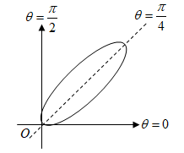

So, the required area of the loop is

A****







putting  

when  then 

when  then 

Now 





** Sq. Units (As desired )**

**Problem-19:** Find the area of a loop of the curve .

**Solution:** Given curve is 

Since *x* and *y* are of even powers, so the given curve is symmetrical about the axes.

Also if *x* and *y* are interchanged, equation (i) remains unaltered and hence the curve is symmetrical about the line .

Again (i) remains unchanged if x and y are changed to  and  respectively. So the curve is also symmetric about the line.

To transform (i) into polar form, we put

 and .

Then (i) becomes,





Equation (ii) remains unchanged if  is changed to . So the curve is symmetrical about the line .

For a loop, we putting in (ii) we have







.

For a loop,  varies from 0 to . Since for  and , we have , so that  and  are the tangents to the curve.

The graph of the given curve is as follows:



So, the required area of the loop is

A****





putting  

when  then 

when  then 

Now 























** Sq. Units (As desired )**

**Problem-20:** Find the area of a loop of the curve .

**Solution:** Given curve is 

Since *x* and *y* are of even powers, so the given curve is symmetrical about the axes.

Also if *x* and *y* are interchanged, equation (i) remains unaltered and hence the curve is symmetrical about the line .

Again (i) remains unchanged if x and y are changed to  and  respectively. So the curve is also symmetric about the line.

To transform (i) into polar form, we put

 and .

Then (i) becomes,





For a loop, we putting in (ii) we have







.

For a loop,  varies from 0 to .

The graph of the given curve is as follows:

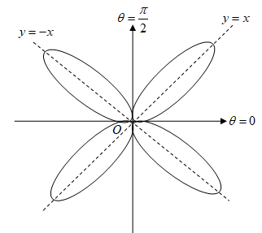

So, the required area of the loop is

A****







putting  

when  then 

when  then 

Now 









** Sq. Units (As desired )**

Note: Total area bounded by the given curve is  **Sq. Units.**

**Try Yourself**

1. Find the area of the circle. Ans:  sq. units
2. Find the area of the ellipse. Ans:  sq. units
3. Find the whole area of the asteroid. Ans:  sq. units

Or Find the area of the asteroid.

Or Find the whole area of the asteroid.

1. Find the area of the region bounded by parabola  and its latus rectum.
2. Find the area bounded by the parabolas and. Ans:  sq. units
3. Find the area of the circle. Ans:  sq. units
4. What is the entire area enclosed by the curve . Ans:  sq. units
5. Find the area of the loop of the curve . Ans:  sq. units
6. Find the area of the loop of the curve .

**Length of Curves (Rectification)**

**Rectification:** Rectification is the process of finding the length of an arc between two given points on the curve.

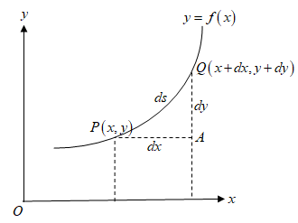

Let  be the curve. Let  and  two neighbouring points on the curve. Let is elementary arc distance between two points and . So from the right angled triangle PQA, we have







Also, 





Let be the required arc of the curve.

.

Also .

**Arc formula for Cartesian equations:**

1. The length of the arc of the curve between the points, where , is given by .



1. The length of the arc of the curve between the points, where , is given by .



**Problem-01:** Find the perimeter of the circle .

**OR**

Find the perimeter of the curve , .

**Solution:** Given curve (circle) is , 



Since *x* and *y* are of even powers, so the given curve is symmetrical about the axes.

Putting  in (i), we get

.

Again putting  in (i), we get

.

So the curve meets the *x*-axis at , and *y*-axis at, .

So *x* varies from 0 to *a* in the first quadrant.

The graph of the given curve is as follows:

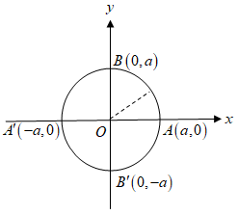

The required perimeter of the given circle is

****length of the curve lying in the 1st quadrant.



Now differentiating (*i*) with respect to *x*, we get





Then (*ii*) becomes,





















** (As desired )**

**Problem-02:** Find the perimeter of the asteroid .

**OR**

Find the perimeter of the curve , .

**Solution:** Given curve (asteroid) is , 



Equation (*i*) remains unchanged if *x* is changed to and *y* is changed to . So the curve is symmetrical about both axes.

Putting  in (*i*), we get

.

Again putting  in (i), we get

.

So the curve meets the *x*-axis at , and *y*-axis at, .

So *x* varies from 0 to *a* in the first quadrant.

The graph of the given curve is as follows:

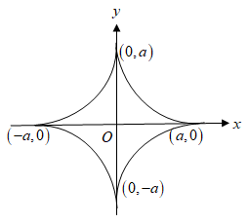

The required perimeter of the given circle is

****length of the curve lying in the 1st quadrant.



Now differentiating (*i*) with respect to *x*, we get





Then (*ii*) becomes,



















** (As desired )**

**Arc formula for Polar equations:**

1. The length of the arc of the curve between the points, where , is given by .
2. The length of the arc of the curve between the points, where , is given by .

**Problem-03:** Find the perimeter of the cardioid .

**OR**

Find the arc length of the cardioid .

**Solution:** Given curve is 

Since by changing  into ****, the equation of the curve remains unaltered, then the curve is symmetrical about the initial line.

Now putting in (*i*) we have









.

So the curve lies between  and .

The graph of the given curve is as follows:



So, the required perimeter of the cardiod is

S ****arc length of the curve which lies above the initial line.



Now differentiating (*i*) with respect to ****, we get



Then (*ii*) becomes,





















** Units (As desired )**

**Assignment:**

1. Find the perimeter of the asteroid .

**OR**

Find the perimeter of the curve , .

1. Find the perimeter of the cardioid .

**Volume and surface area of solids of revolutions**

If a plane curve is revolved about some axis in the plane of the curve, then the body so generated is known as solid of revolution. The surface generated by the perimeter of the curve is known as surface of revolution and the volume generated by the area is called volume of revolution.

**Volume formulae for Cartesian Equations:**

1. **Revolution about *x*- axis:** The volume of the solid generated by the revolution of the area bounded by the curve , *x*-axis and the ordinates about the *x*-axis is

.

1. **Revolution about *y*- axis:** The volume of the solid generated by the revolution of the area bounded by the curve , *y*-axis and the ordinates about the *y*-axis is

.

1. **Volume between two solids:** The volume of the solid generated by the revolution of the area bounded by the curves ,  *x*-axis and the ordinates  about the *x*-axis is

.

where  is the upper curve and is the lower curve.

**Volume formulae for Polar Curves:** The volume of the solid generated by the revolution of the area bounded by the curve and the radius vectors .

1. about the initial line OX is.
2. about the line OY is.
3. about the any line is.

**Surface formula for Cartesian Equations:** The curved surface of the solid generated by the revolution of the area bounded by the curve , *x*-axis and the ordinates about the *x*-axis is

.

**Surface formula for Polar Equations:** The curved surface of the solid generated by the revolution of the area bounded by the curve and the radius vectors about the initial line is

.

**Problem-01:** The circle  is revolved about x-axis. Find the volume of the sphere

so formed. Also find the surface area of a sphere generated by this circle about

*x*-axis.

**Solution:** Weknow, the sphere is the solid for revolution generated by the revolution of a semi-circular area about its bounding diameter.

Let the equation of the circle of radius *a* is



Now for the semi-circle above the *x*-axis, *x* varies from  to *a*.

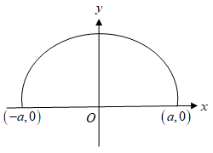

So, the required volume of the sphere is









****.

**2nd part:** Differentiating (*i*) with respect to ****, we get





Now









****.

The required surface area is











****.  **(As desired )**

**Problem-02:** The circle  is revolved about y-axis. Find the volume of the sphere

so formed. Also find the surface area of a sphere generated by this circle about

*y*-axis.

**Solution:** Weknow, the sphere is the solid for revolution generated by the revolution of a semi-circular area about its bounding diameter.

Let the equation of the circle of radius *a* is



Now for the semi-circle positive side of *y*-axis, *y* varies from  to *a*.

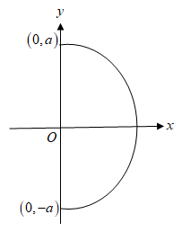

So, the required volume of the sphere is









****.

**2nd part:** Differentiating (*i*) with respect to *y*, we get





Now









****.

The required surface area is











****.  **(As desired)**

**Problem-03:** For the curve find the volume of the solid formed by the revolution of the curve about any axis and the area of the surface so formed.

**OR**

For the curve , find the volume of the solid formed by the revolution of the curve about any axis and the area of the surface so formed.

**Solution:** Given curve (asteroid) is



The parametric equation of the given curve is

, 

Equation (*i*) remains unchanged if *x* is changed to and *y* is changed to . So the curve is symmetrical about both axes.

Putting  in (*i*), we get

.

Again putting  in (*i*), we get

.

So the curve meets the *x*-axis at , and *y*-axis at, .

So *x* varies from 0 to *a* in the first quadrant.

The graph of the given curve is as follows:



The required volume is

****volume generated by the arc in the 1st quadrant about *x*-axis.



Since  and , so 

when  then  and when  then .

Then (*iii*) becomes









 



****.

**2nd part:** Now differentiating (*ii*) with respect to , we get

 and







The required surface area is

****surface area generated by the arc in the 1st quadrant about *x*-axis.









 



****. **(As desired)**

**Problem-04:** The area enclosed by the parabolas and is revolved about the *x*-axis. Show that the volume of the solid formed is .

**Solution:** The given equations are





Solving the equations (*i*) and (*ii*), we get











Substituting the values of *y* in (*i*) or (*ii*), we get

.

The point of intersection of the two parabolas are and . So *x* varies from 0 to 4*a* in the first quadrant.

The graph of the given curve is as follows:

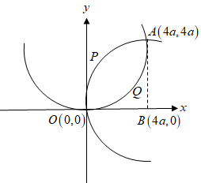

The required volume is

****(volume generated by the revolution of arc OPA about *x*-axis) -(volume generated by

the revolution of arc OQA about *x*-axis).











****. **(Showed)**

***Assignment:***

**Problem-01:** Findthe volume of the solid generated by revolving the ellipse  about the *x*-axis.

**Problem-02:** Findthe volume of the solid generated by revolving the ellipse  about the *x*-axis.